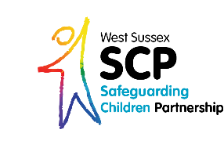
Child Exploitation
Practitioner Survey
- Have you attended child exploitation training? (Please delete those that don’t apply)
- Yes in the last year
- Yes in the last 2 years
- Yes in the last 3 years
- No I haven’t
- Was this training online or face to face?

- Please state how confident you feel in (Please delete those that don’t apply):
- Identifying child exploitation: Not confident Quite confident Very confident
- Responding to child exploitation: Not confident Quite confident Very confident
- Evidencing child exploitation: Not confident Quite confident Very confident

- Please tick the following statements that apply to your current safeguarding practice in relation to child exploitation (Please delete only those that do not apply)
- I know where to find resources and tools to support my work around child exploitation
- I have the opportunity to discuss my cases with colleagues, my manager / supervisor
- I have a set time or regular opportunities to reflect on “stuck” current cases
- My manager/supervisor encourages me to attend training to increase my knowledge and confidence around child exploitation

- What do you feel is working well regarding your work around supporting those children who are at risk of/currently being exploited?
(Please type here)….

- What do you feel could be improved regarding your work around supporting children who are at risk of/currently being exploited?
(Please type here)….

- Have you used the child exploitation referral form?
(Please delete the response that does not apply)
Yes
No

Thank you for completing this short survey. Please return by email to Lucy.Short@westsussex.gov.uk

